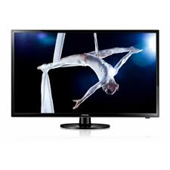

Samsung F4000

* Free view Tuner
* Energy Efficiency A+
* Size Inch: 32
* MHEG 5 System
* **Rs.30,499**